

BTIO42
USB I/O Card
15B110021-1001
USB Custom HID, Game Port, Joystick Port

User and Interface Manual
Part # 15B180002-1001

Chris Ruff
Revision 2.00
10-28-2021

Copyright
Bugeye Technologies 2021

Table of Contents

Contents
1.0 BTIO42 Overview 3
2.0 BTIO42 USB communication 7
3.0 BTIO42 Digital Inputs 9
4.0 BTIO42 USB Packet Information 10
5.0 BTIO42 Boot Monitor Operation, the Button and the LED 13
6.0 BTIO42 Hardware Information 14
7.0 BTIO42 Support Applications 16
8.0 BTIO42 Procedures 22
9.0 BTIO42 Letter of Volatility 27
Contact Information 30

BTIO42 Overview

In this document “Device”, “the device”, “this device”, “the board”, or “this board” all refer to the BTIO42 USB I/O board.

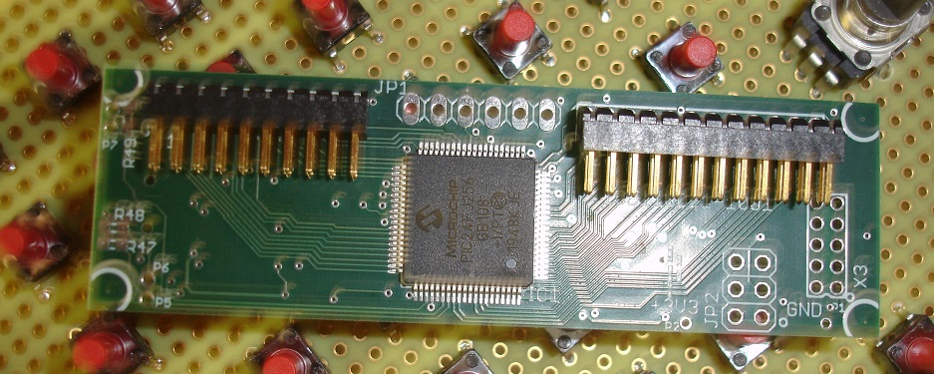
This device listens to analog and digital inputs and packages the input values for transmission to the USB attached host computer via Master/Slave Custom HID Reports, or Asynchronous Game Port Reports, or Asynchronous Joystick Reports.
The device is powered by the USB cable.
When USB communication is via a custom HID-based device interface, Bugeye supplies a working HID client application, BTIO42Client200.exe, and the source code for this application is provided to the customer to assist in developing the host-side software.
When USB communication is via Game Port or Joystick device interfaces, the first 32 digital inputs and the analog inputs are sent in the Game or Joystick Report format.

The firmware is easily updated using the BTIO42Config200.exe application, as well as specifying the USB communication mode and calibrating the 8 analog channels.

The board provides 42 Low active inputs Each digital input is internally pulled up with a 4.7k resistor up to +3.3 Volts.
8 analog inputs are provided. Analog inputs 1-8 have an active voltage range of 0-3.3 volts. The 10-bit resolution analog lines are attenuated with a 0.1uF cap on each input to ground.
Each of the 8 analog inputs can be sent out RAW or Scaled. Scaled analog inputs calibrated to a certain type of control, either:
“end-zero” or “center-zero”.

The goal of the calibration of a given analog control/input is quiet operation at “hands-off” time and as the control is moved, the previously quiet number will commence its count up or count down in the direction the control is moved when the control is moved off of the “dead band” and into the active area of the control’s travel.
In an end-zero (AKA 1-Range) calibrated axis, the minimum reported value to the client will be zero and the largest value reported will be 32767. A dead band is specified at the minimum counts end and up to any calibrated position above that.
In the center-zero (AKA c-zero) calibration, the full minimum direction will report zero, the full maximum value reported will be 32767. The dead-band (AKA DB) zone will be roughly in the center near 16382, but the calibration procedure and the calibrating person specifies by calibration-time actions whatever that value will be with the specific hardware that is being calibrated to the board. The calibration procedure allows the operator to insert a dead band window near the center of mechanical travel. A possible center-zero calibration result:

 | minimum | Db low | Db high | maximum
AD counts | 532 | 657 | 673 | 1855
Output value | 0 | 16300 | 16300 | 32767

When the control is in the center position (~660 counts here), there will be no update of the reported number to the host until the axis is moved either down to 656 counts or up to 674 counts- at which point the numbers will descend or climb.

The board stores the calibration data in EEPROM for the 8 analog channels. The calibration points can be read out of the board and can be written to the board using Windows application BTIO42Config200.exe. Configuring the BTIO42 places the board into Custom-HID mode. Calibration can only be achieved in Custom-HID USB mode. After calibration is complete, the operator can place the board into USB Game Port Mode or into USB Joystick Mode if desired.

The board provides two different digital input modes, SCN40 and DIN42. In DIN42 each input is reported individually in the USB data packet. In SCN40 mode 4 of the digital lines become drivers and 10 lines are sampled to find keypresses in the 4x10 array. The last 14 lines in the digital interface are used for this purpose.

The board provides a PWM output line that is available to drive backlight LED circuitry. The PWM duty cycle is adjustable and is saved for subsequent power-ups.
The USB modes: Custom-HID, Game Port, and Joystick Mode support different kinds of USB channel activity. In Custom-Hid mode the computer USB code treats the BTIO42 as a slave and the board responds to messages generated by the host in a 2-way communication mode. In Game Port mode, the BTIO42 sends one-way USB messages asynchronously that conform to the legacy Game Port report format. In Joystick Port mode, the BTIO42 sends one-way USB messages asynchronously that conform to the legacy Joystick Port report format. Game Port and Joystick modes are supported in operating systems with built-in applets from the OS manufacturer.

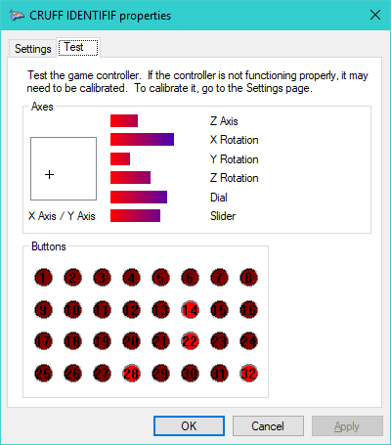
This is an example of the Windows XP/8/10 Game Controller built-in applet
- X Axis: BTIO42 channel 1
- Y Axis: BTIO42 channel 2
- Z Axis: BTIO42 channel 3
- X Rot: BTIO42 channel 4
- Y Rot: BTIO42 channel 5
- Z Rot: BTIO42 channel 6
- Dial: BTIO42 channel 8
- Slider: BTIO42 channel 7

Custom-HID requires custom software built by the customer using the BTIO42 in Custom-HID mode.

The board provides the capability to readout the raw AD values directly through the normal analog interface values. The choice of raw versus scaled analog outputs may be chosen in the calibration application and saved to on-board storage so that the board wakes up in the desired analog readout mode. See the calibration application specification later in this document.

The board allows the operator to read the analog values reversed. In this manner, a mechanical control axis can have the dead band moved to either end of travel.

Any given analog channel can be set up to support:
- C-zero or 1-range (scaled)
- Raw or scaled readback
- Normal or reverse readback of raw or scaled analog

When the board is calibrated the BTIO42 USB mode is set to Custom-HID and it remains in this mode until the operator places the board into Game or Joystick mode.

When powering up the BTIO42 by plugging-in the USB cable, the button is held down by the operator until the green LED flashes once. Then the board is “sitting in the Boot Monitor” and the following configuration changes are automatically set in the BTIO42:
- The PID is set to 2928 (hex 0b70)
- The USB Type is set to Custom-HID

After either calibrating the unit, changing a parameter (such as Ident String), or updating the firmware, the BTIO42 will continue to connect at PID 2928 and in Custom-HID mode until they are changed back to any possible previous setting by the calibration person. See the procedures below to assign a different PID or a different USB Mode (game, joystick).

Note: The BTIO42 application, boot monitor, and supported applications have all been changed starting at version 2.x. The USB VID has been changed from the original 16D0 to 3475. The USB PID list has been expanded from the original 8 values to 0-32767 now. The PIDs were originally specified in the hexadecimal (0b70, 0b71, etc.) and now this document and the support applications are specifying PIDs in the decimal. The boot, app, support applications are all changed to revision 2.00 and greater.

BTIO42 USB communication

The BTIO42 supports: Game Controller, Joystick, and Custom HID modes. The USB mode that is previously programmed (using BTIO42Config.exe) into the BTIO42 is the mode the board wakes up in when powered up.

BTIO42Config200.exe operates differently with the BTIO42 when it is sitting in the Boot Monitor than when BTIO50 is executing the Application firmware.

The method to get the BTIO42 to launch and stay in the Boot Monitor is to
- Unplug the BTIO42/stick
- Hold in “the Button”
- Plug the BTIO42/stick into the host computer and continue to hold in the button.
- The BTIO42 LED will flash Orange a few times and then one Green flash. Now the button may be released and the BTIO42 will remain in the boot monitor in Custom HID mode, at PID:2928.

This USB 2.0 device supports one VID: 3475 and PIDs between and including 0-32767, allowing many boards at once to be attached to the host computer. Each board draws 120-200mA from the host machine. When backlights are being powered by the USB cable the current draw is variable depending on the amount of LEDs. USB ports are generally specified to source < 1 AMP.

The IDENT string (set in BTIO42Config200.exe) is made available to the operating system. The string can be seen in the HID device listings in the Devices listing in the HOST operating system. The default Ident string is “BTIO42 STICK IFC BOARD”. After entering and saving the new Ident string in BTIO42Config application a procedure needs to be performed before the new string will appear in various applications.

The Identification String Operating System Issue

After changing the Ident String in BTIO42Config200.exe, the board/stick is unplugged and the OS previously saved instance of the original string needs to be searched and destroyed in the host computer. When the board is plugged back in the new string will be logged in the host computer.
In Windows the previous IDENT string is stored in the Registry with the string value name OEMNAME. Search for the old string, then delete the string value. The next time the stick is plugged in the new IDENT string will be logged into Windows and saved in the Windows registry, and will show up in your application.

Custom-HID USB Communications Mode

When the BTIO42 is operating in Custom-HID mode, there are two readback modes: DIN42 and SCN40. In DIN42 mode, all 42 digital inputs are read separately and reported uniquely- bit for bit. The other readback mode is SCN40 mode. In SCN40 mode: 14 of the digital inputs are handled differently than in DIN42 mode.

The board will respond in SCN40 or DIN42 mode based on which call is made to the board. This is documented below

The board backlight brilliance value can be changed at run-time. This is documented below

BTIO42 Digital Inputs

SCN40 digital input Mode, DIN42 input mode

In order to increase the amount of switches/buttons to 68 discrete inputs, The BTIO42 is capable of scanning 40 inputs in a scanned array of 4x10.

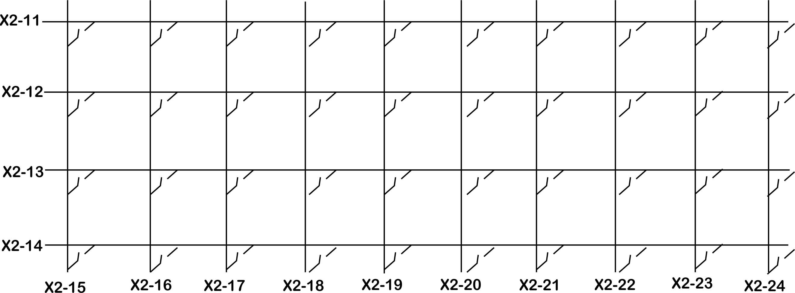

Pins X2-11 through X2-14 are changed to outputs and provide scan drive for the pins X2-15 through X2-24. When a button in the scan array closes a drive signal to an input signal, after a debounce cycle, a bit is set high in the outgoing SCN40 byte set. In DIN42 mode the 42 grounded-ON digital inputs are packaged in the outgoing DIN42 Bytes. The DIN42 and SCN40 digital bits are packed, along with the 8 analog inputs, and made available to the host computer at (at least) 85hz throughput.

The output arrays transferred over USB have undetermined bits depending on the input mode the board is running in.

When the board is running in DIG42 mode, Scan bytes 1-5 values are undetermined and should be ignored.

When the board is running in SCN40 mode, Dig BYTES: byte 4, bits 28-32, byte 5 and byte 6 values are undetermined and should be ignored, Scan bytes 1-5 are in service.

BTIO42 USB Packet Information

The following table lists the assignment locations in the 64-byte packet transmitted to the host computer. The analog words are built from two bytes as shown. The source code later in the document also shows the shift/or operation to build a WORD from the BYTEs. *the specified offset is a function of the operating system USB Custom HID device driver. Yours might be shifted by one byte*

USB Client App->Board

Custom-HID Mode USB packet Inputs

When the BTIO42 is operating in the custom-HID mode the host computer sends this 64-byte string, the BTIO42 will respond with the information specified in the next section.
To send a packet that will get a response from the BTIO42, you need to set the outgoing buffer in the manner shown here. The trigger is set to 1 for only one transfer. Send the buffer and the BTIO42 will respond with a packet shown below

Name | Value | Byte Offset | Description
Not used | 0 | 0 | Report ID
Sig1 | 0xfa | 1 | Magic signature- 4 bytes
Sig2 | 0xda | 2
Sig3 | 0xba | 3
Sig4 | 0xba | 4
Mode | 0,1 | 5 | 0 = DIN42, 1 = SCN40
trigger | 0,1 | 6 | Set to 1 to send this packet
unused | 0xff | 7-63 | Fill these with 0xff

Board->Client App

Custom-HID USB packet Outputs

Ana WORD | Byte Offset | description
0 | 4(lo) 5 (hi) | Analog channel 1
1 | 6(lo) 7(hi) | Analog channel 2
2 | 8 | Analog channel 3
3 | 10 | Analog channel 4
4 | 12 | Analog channel 5
5 | 14 | Analog channel 6
6 | 16 | Analog channel 7
7 | 18 | Analog channel 8
Dig BYTE | offset | Description
1 | 24 | Inputs Bits I1-I8
2 | 25 | Inputs Bits I9-I16
3 | 26 | Inputs Bits I17-I24
4 | 27 | Inputs Bits I25-I32
5 | 28 | Inputs Bits I33-I40
6 | 29 | Inputs Bits I41-I42 (lower 2 bits)
Scan BYTE | offset | Description
1 | 30 | Scanned Bits S1-S8
2 | 31 | Scanned Bits S9-S16
3 | 32 | Scanned Bits S17-S24
4 | 33 | Scanned Bits S25-S32
5 | 34 | Scanned Bits S33-S40

Game, Joystick USB packet Outputs

Dig BYTE | offset | Description
1 | 0 | Inputs Bits I1-I8
2 | 1 | Inputs Bits I9-I16
3 | 2 | Inputs Bits I17-I24
4 | 3 | Inputs Bits I25-I32
5 | 4 | Inputs Bits I33-I40
6 | 5 | Inputs Bits I41-I42 (lower 2 bits)
Scan BYTE | offset | Description
1 | 6 | Scanned Bits S1-S8
2 | 7 | Scanned Bits S9-S16
3 | 8 | Scanned Bits S17-S24
4 | 9 | Scanned Bits S25-S32
5 | 10 | Scanned Bits S33-S40
 | 11-15 | 0xff
Ana Word
1 | 16 | Analog Channel 1 (X)
2 | 18 | AnalogChannel 2 (Y)
3 | 20 | AnalogChannel 2 (Z)
4 | 22 | AnalogChannel 2 (rX)
5 | 24 | AnalogChannel 2 (rY)
6 | 26 | AnalogChannel 2 (rZ)
7 | 28 | AnalogChannel 2 (slider)
8 | 30 | AnalogChannel 2 (dial)

BTIO42 Boot Monitor Operation, the Button and the LED

The BTIO42 button and the dual color LED are provided at the outside of the stick assembly to allow the operator to stop the BTIO42 in the boot monitor for firmware updates or BTIO42 Board Configuration.

The dual color LED Orange/Green provides feedback to the operator.

- When the Orange LED is flashing the BTIO42 is sitting in the boot monitor and can be communicated with by the application BTIO42Config200.exe for certain operations.
- The Green LED flashed once to indicate that the Boot Monitor has been locked on.
- The green LED flashes when calibration and parameter changes are made in the app BTIO42Config200.exe

BTIO42 Hardware Information

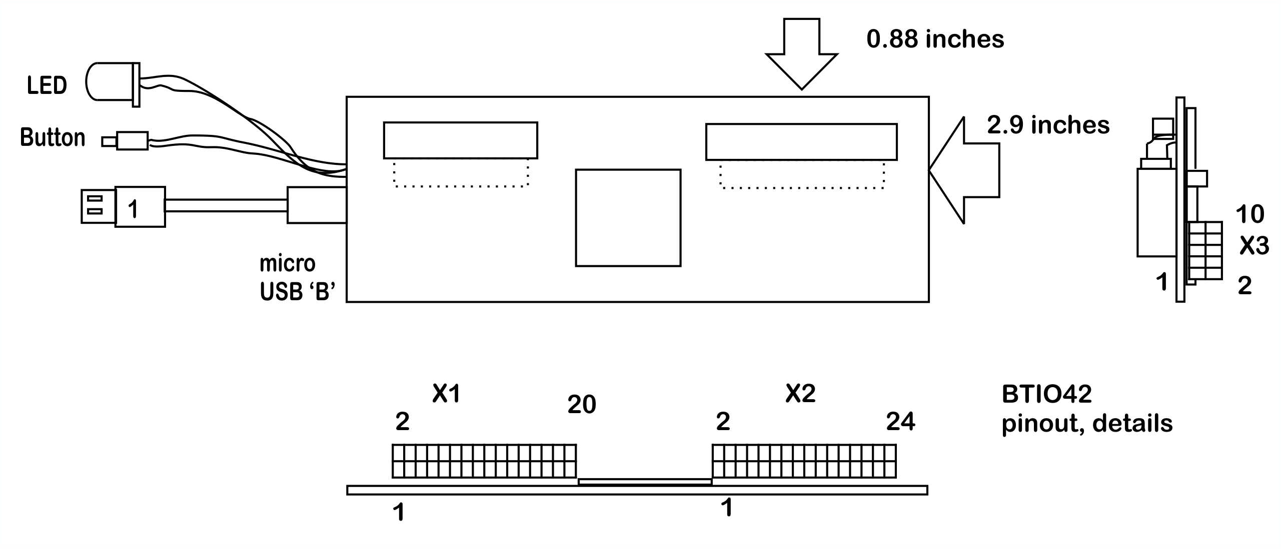

 | 2mm pins: X1 digital signals
1 | GND signal
2 | Din1
3 | Din2
4 | Din3
5 | Din4
6 | Din5
7 | Din6
8 | Din7
9 | Din8
10 | Din9
11 | Din10
12 | Din11
13 | Din12
14 | Din13
15 | Din14
16 | Din15
17 | Din16
18 | Din17
19 | Din18
20 | +3.3 Volts REF
 | 2mm pins X2 digital signals
1 | Din19
2 | Din20
3 | Din21
4 | Din22
5 | Din23
6 | Din24
7 | Din25
8 | Din26
9 | Din27
10 | Din28
11 | Din29, Scan Output 1
12 | Din30, Scan Output 2
13 | Din31, Scan Output 3
14 | Din32, Scan Output 4
15 | Din33, Scan Input 1
16 | Din34, Scan Input 2
17 | Din35, Scan Input 3
18 | Din36, Scan Input 4
19 | Din37, Scan Input 5
20 | Din38, Scan Input 6
21 | Din39, Scan Input 7
22 | Din41, Scan Input 8
23 | Din41, Scan Input 9
24 | Din42, Scan Input 10
 | 2mm pins: X3 Analog signals
1 | GND signal
2 | Ana1
3 | Ana2
4 | Ana3
5 | Ana4
6 | Ana5
7 | Ana6
8 | Ana7
9 | Ana8
10 | +3.3 Volts source voltage

BTIO42 Support Applications

Change USB Parameters, Update firmware with BTIO42Config200.exe

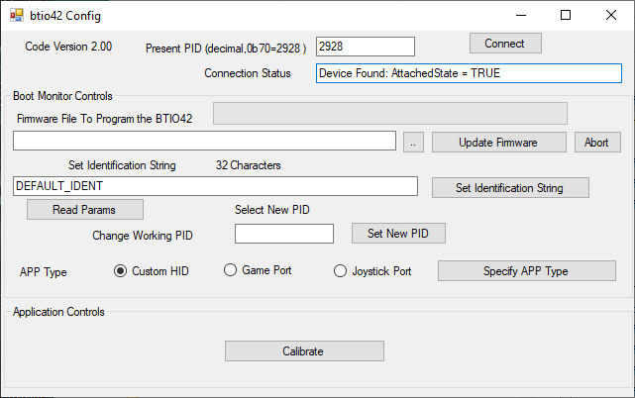
This windows application performs the following tasks when the BTIO42 is in the Boot Monitor (orange LED is flashing):
- Update firmware in the BTIO42 board
- Specify which PID will be used for the USB HID assignment on next power-up
- Set the identification string that shows up in the host OS.
- Set the USB type (Custom HID, Game Port, Joystick)
This application performs the following tasks when the BTIO42 is in the Application:
- Calibrate the 8 analog inputs
- Get/Set the backlight brilliance value
- Get the firmware Version
- Get/Set the SCN40 enable non-volatile bit

Click “Read Params” to fill the fields: “… Identification String” and “Select New PID”.

The “Custom HID” radio button will always be selected when the board is stopped in the Boot Monitor.

BTIO42 Configuration Overview

All communication, configuration, and power take place over the USB cable. This makes simple changes to a configuration parameter complicated.

Generally Speaking:
- Any change made to the board requires unplugging and plugging the USB connector at least once.
- Certain parameters are changed in the boot monitor
- The remaining parameters are changed when the BTIO42 is executing the Custom-HID app firmware
- Certain parameters cannot be “seen” or displayed on a screen. The APP type (Custom-HID,Game,Joystick) and the PID selected are write-only from a programming/calibration perspective
- When the BTIO42 is powered up into the boot monitor by holding the button down, the PID is set to 2928, the APP Type is set to Custom-HID, every time.
- After changing either the APP type, the PID, or both: unplug the USB cable and plug it back in. The Board will come up in the APP type and the PID you just set

Follow the procedures below to make the changes.

View the 8 analog output values, Set the backlight value, Specify SCAN mode, get the F/W version

When the BTIO42 is in the application and the LED is not flashing: from the main screen click the button “Calibrate”. The following screen appears:
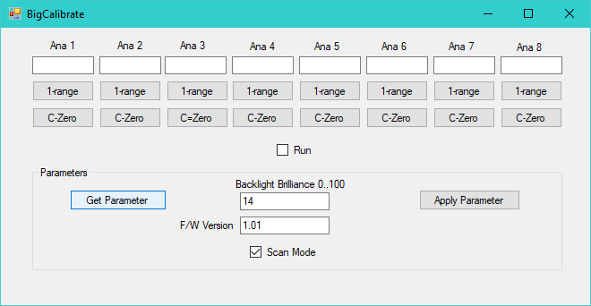
Click the “Run” checkbox and the 8 analog values will appear continuously updated in the 8 text boxes.

Click the “Get Parameter” button and the fields “Backlight Brilliance” “F/W Version”, and the checkbox “Scan Mode” will show the present state of these system-level parameters.

When the backlight brilliance is set to a value and the “Apply Parameter” is clicked, the backlight value is written to the BTIO42 non-volatile memory. Any time the BTIO42 wakes up it will provide the PWM value to the backlights that was previously set. In Game and Joystick Port modes the value cannot be changed at run-time since the board is not listening. In Custom-HID mode the backlight brilliance can be changed at any time.

The board operates in DIN42 or SCAN40 modes depending on the last set mode by the calibrating person. When the board is operating in Game or Joystick mode, the board will wake up in whatever SCAN mode was last programmed by the calibration person. In Custom-HID mode the SCAN mode can be changed on-the-fly.

Calibrate 8 Analog inputs with application BTIO42Config.exe

View analog inputs in the C-zero, 1-Range formats. Specify Raw/Scaled modes. Calibrate dead-band zones using the mechanical control with this application, save calibration settings to the board.

Assuming that an analog signal source is connected to the Ana 1 input:
- From the “Big Calibrate” screen, press the 1-range button on Ana 1 channel.
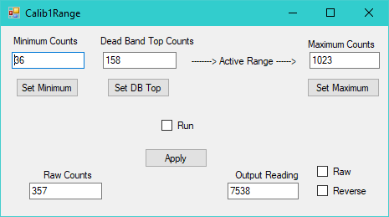
This dialog will appear.
Run the procedure below to calibrate 1-Range mode.
- From the “Big Calibrate” screen, press the C-Zero button on Ana 1 channel.
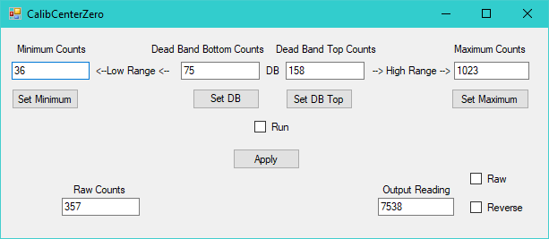
This dialog will appear.
Run the C-Zero procedure below to calibrate the analog channel in center-zero mode.

View Analog and Digital data with BTIO42Client200.exe

View USB channel digital and analog inputs

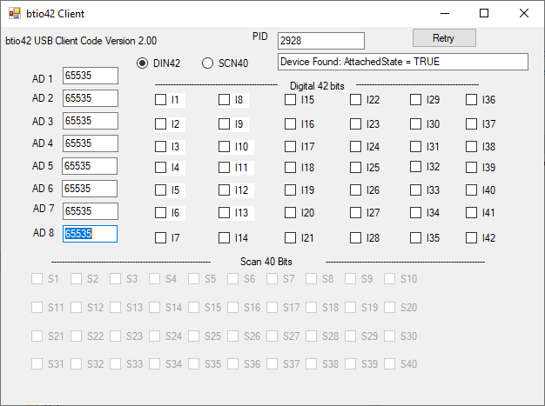
DIN42 mode- each digital input is discrete
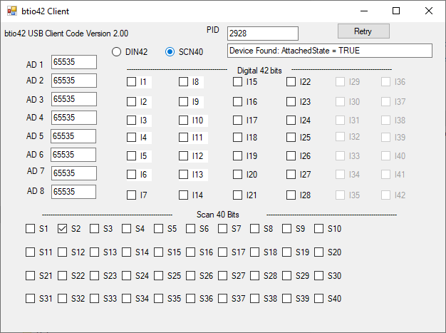
SCN40 mode- 28 discrete digital inputs and 40 (4x10) scanned inputs.

This is a managed C++ application that can be built with Visual Studio 5.0 and greater. The main features of this application are:
- Discovering the HID device in the OS list
- Unpacking the data transmitted from the BTIO42 board and displaying it.
- Operating the BTIO42 in DIN42 or SCN40 modes
- Displaying the state of the digital discrete inputs, analog inputs, and scanned inputs when the BTIO42 is operating in SCN40 mode.

This is a Custom HID application. The BTIO42 is a slave and Windows/ this app is the master.

BTIO42 Procedures

Firmware Update

- Open BTIO42Config200.exe
- Hold Button Down
- Plug in USB cable
- Continue holding button until the LED flashes Green once
- Release the button
- LED is now flashing Orange
- BTIO42Config200: Set PID to 2928 if not already there
- Press “Connect” if necessary. Status line should include “…TRUE”
- Click “…” button and find the BTIO42App[version].hex file
- Click “Open”
- Click “Update Firmware” button
- After a second the progress control will indicate the firmware downloading
- The BTIO42 is now running the new version of firmware
- Unplug the USB cable and plug it back in for a clean start

Change PID, select USB Mode, set IDENT string

- Open BTIO42Config200.exe
- Hold Button Down
- Plug in USB cable
- Continue holding button until the LED flashes Green once
- Release the button
- LED is now flashing Orange
- BTIO42Config200: Set PID to 2928 if not already there
- Press “Connect” if necessary. Status line should include “…TRUE”
- Enter new PID into “Select New PID” text box or leave it as is. If you change it click “Set New PID” button.
- Enter new IDENT string in “32 characters” text box or leave it as is. If you change it click “Set Identification String”.
- Click “APP Type” radio buttons to new APP Type or leave it as is. If you change the APP Type click the “Specify APP Type” button.
- Unplug the BTIO42 USB cable.
- Close BTIO42Config200.exe.
- Plug in the USB cable, the board will operate at the PID and in the Mode you have selected.

To Calibrate BTIO42

- Open BTIO42Config200.exe
- BTIO42Config200: Set PID to the previously selected value.
- Press “Connect” if necessary. Status line should include “…TRUE”
- Click “Calibrate” button
- The dialog shown below will appear
- Click “Run” to see the present analog values, change them by moving the necessary mechanical devices.
- Click a channel’s “1-range” button to calibrate that channel’s 1-range settings
- Or click a channel’s “C-Zero” button to calibrate that channel’s c-zero settings
- Follow the procedures below for these two axis types
- After you have calibrated the specific channel’s numbers, click “Run” and move the controls to see the results of your calibration work
- Click the corner X to leave the calibration main dialog
- Exit BTIOConfig200.exe

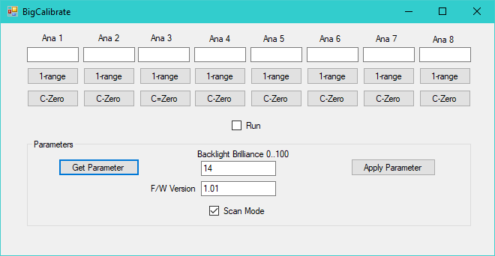

Calibrate 1-Range

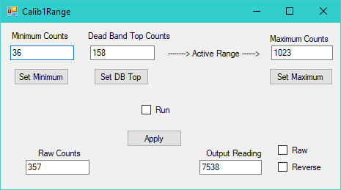

- Click the “Run” checkbox
- Pull the control to its minimum counts (shown in “Raw Counts” window) position
- Click “Set Minimum”. Run will automatically be unchecked. You can hand-modify the value captured if desired in the Minimum Counts edit box
- Click Run
- Move stick to the top of the dead band (not the top of travel)
- Click “Set DB Top” button
- Click Run
- Move stick to the maximum counts position
- Click “Set Maximum” button
- Click “Apply” button
- Click “Run” and move the stick through its travel. Note the output Reading window to see the results of your calibration work. The numbers will not change between Minimum and DB Top and then will rise when the control is moved toward Maximum

Calibrate C-Zero

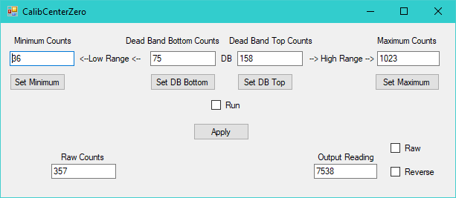
- Click the “Run” checkbox
- Pull the control to its minimum counts (shown in “Raw Counts” window) position
- Click “Set Minimum”. Run will automatically be unchecked. You can hand-modify the value captured if desired
- Click Run
- Move stick to the bottom of the dead band
- Click “Set DB Bottom” button
- Click Run
- Move stick to the top of the dead band
- Click “Set DB Top” button
- Click Run
- Move stick to the maximum counts position
- Click “Set Maximum” button
- Click “Apply” button
- Click “Run” and move the stick through its travel. Note the output Reading window to see the results of your calibration work. The numbers will not change when in the deadband window somewhere in the travel between minimum and maximum.

To Set/Get BTIO42 Backlight/Scan Parameters

- Open BTIO42Config200.exe
- Unplug the USB Cable
- Hold Button Down
- Plug in USB cable
- Continue holding button until the LED flashes Green once
- Release the button
- LED is now flashing Orange
- BTIO42Config200: Set PID to 2928 if not already there
- Press “Connect” if necessary. Status line should include “…TRUE”
- Click “Calibrate” button
- The dialog shown above will appear
- Click “Get Parameter” to see the present values of Backlight Brilliance, Scan Mode.
- The backlight value is between 0 and 100 and you can see the result on the device as you change and click “Apply Parameter”
- Click the “Scan Mode” checkbox if you want the board to wake up in Scan mode or unchecked to wake up in DIN42 mode
- After you have made all the changes you need- you are done (if you are running on 2928 and in Custom-HID mode). If you need to change the APP type or the PID you will need to run another procedure to get back into your required App type/PID.
- Click the corner X to leave the calibration main dialog
- Exit BTIOConfig200.exe

BTIO42 Letter of Volatility

Title:
Letter of Volatility, Bugeye BTIO42
Prepared By: |  |  | Dept | Date: | Checked By: |  | Dept |  | Date:
Chris Ruff |  |  |  | 4-16-2020
Approved by: |  |  | Dept | Date: | Quality Assurance Approval: |  | Dept |  | Date:
Rev | ECN No. | Description of change |  |  |  | Date: |  | Approved by:
A |  | Production release |  |  |  | 4-16-2020

BTIO42 - Letter Of Volatility

The following details the non-volatile memory storage that exists within the BTIO42 product.

- 16 K Bytes of RAM
The BTIO42 contains 16,384 bytes of RAM for system operation. This memory is volatile with the contents persisting only while the product is powered up. Once power is removed, the content of RAM is lost.

- 256K Bytes of FLASH Memory
The BTIO42 contains 256K bytes of FLASH memory. This memory is non-volatile, meaning that it retains its content through power down and power up events.
This memory is used for two purposes: Storage of the Boot Monitor, storage of the product’s application firmware.

The FLASH memory can be programmed with executable firmware via the USB port with custom-HID packets by a specific application or via an external hardware programming device. Random data cannot be written into the flash by any other method. There is no MSD or thumb drive interface, for instance. Only valid S-records can be loaded into the main flash area using the monitor firmware or using the hardware programmer. The records copied into the flash memory space must be a valid executable program. Access to the in-circuit programming capability requires access to the BTIO42 card, installation (soldering in) of a programming header that is not factory installed in the board, a specialized programming cable, and an in-circuit programming device. The FLASH memory is not directly accessible via any port.

The FLASH memory could be sanitized by writing HEX records over the address range desired to be cleaned. NOTE: OVERWRITING THE FLASH MEMORY WILL RENDER THE BTIO42 INOPERATIVE AND WILL NECESSITATE THE RETURN OF THE UNIT TO THE BUGEYE FACTORY FOR SERVICING.
- 256K Bytes of Non-Volatile EEPROM memory
The BTIO42 contains an EEPROM chip that can only be programmed/read by the microcontroller on the board. There is no method that a user can get to this memory.

    - Product Information

Product registration and application information

Serial Number: _________________________________________________

Purchase date: _________________________________________________

Installation Notes:

Contact Information

On the web at:

WWW.BUGEYETECH.COM

support@bugeyetech.com

sales@bugeyetech.com

Bugeye Technologies
7 Progress Pkwy.
Union MO 63084
USA

Telephone 636 257 3530

